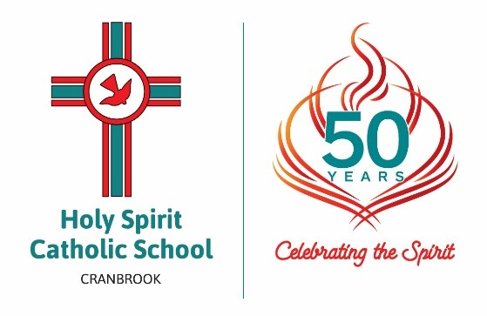
HOLY SPIRIT
CATHOLIC SCHOOL

Celebrate the 50th Anniversary of Holy Spirit Catholic School by purchasing an engraved paver to help us pave the way for another 50 years of education. This is an opportunity to cement your place in Holy Spirit Catholic School’s history.
The deadline for purchasing a paver is 18 October 2019.

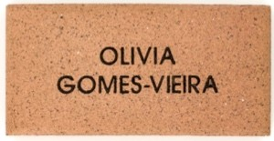

Cost of $25 provides you with a personalised engraved paver in recognition of your
contribution and support.
OFFER CLOSES 18 October 2019
