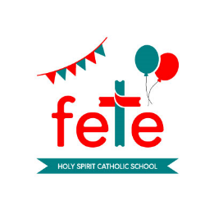
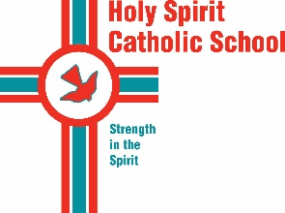
2020 Fete Dodgers
A friendly reminder…..

Dear Parents and Carers

In Term 1, your family was issued with dodger booklet/s. I understand that due to the impact of Covid-19 and as many children have been learning remotely the dodgers may not have been returned to school.
Due to the value of the prizes, we are bound by regulations to have the dodgers returned, sold or unsold.

I understand that many families have experienced financial duress and consequently may not be able to buy dodgers this year. The sale of even two or three tickets will be a support to the school.

In consultation with the Holy Spirit CAFE (Community and Friends’ Engagement), the fete committee has made the decision to extend the timeframe for the selling of dodgers. Could you please advise anyone who has purchased dodgers of the new date for the draw, Friday, 12 June.

Please return dodgers (sold or unsold) by Monday, 8 June in preparation for the draw, Friday 12 June.

If you have lost/misplaced the dodgers, please complete and return the form below by Monday, 8 June.

Thank you to the families and friends who have purchased and returned dodgers.

On behalf of the Fete Committee, kind regards

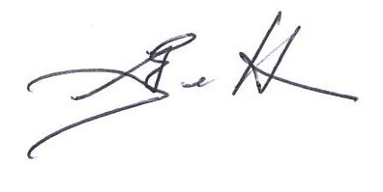

Geraldine Egelton
Principal

_______________________________________________________________________________

Holy Spirit School 2020 Fete Dodgers

(Not received/lost/misplaced Dodgers)

The following Dodgers were not received/misplaced or lost.
(please circle where applicable):

Booklets_________________________________________________________

_________________________ ___________________________________
Parent/Carer Name Parent/Carer Signature

_______________________________________________

Eldest Child’s Name & Class

