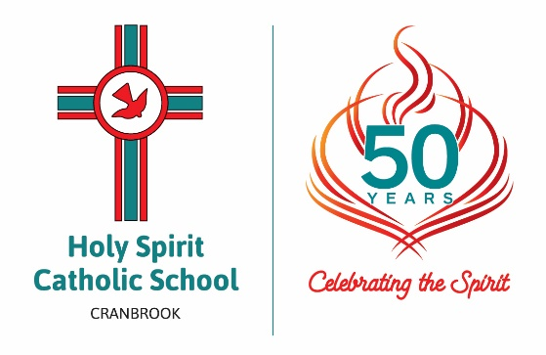
Hatchett Street, Cranbrook, Townsville
Postal Address: PO Box 26, Aitkenvale Qld 4814

Telephone: (07) 4779 4255
Facsimile: (07) 4779 7580
Email: crnbrk@tsv.catholic.edu.au
Website: www.hsstsv.catholic.edu.au

CODE OF DRESS

- The Holy Spirit Catholic School uniform should be worn with pride on all occasions. It is all our collective responsibility (parents, students and staff) to ensure the Code of Dress requirements apply to all students. Uniforms can be purchased from ‘School Locker’ which is situated at the Domain Centre.
- Students must wear the school uniform according to the following rotation:

MONDAY FORMAL
TUESDAY SPORTS
WEDNESDAY FORMAL
THURSDAY SPORTS
FRIDAY SPORTS OR FORMAL

- The following jewellery may be worn at school. The selection is primarily based on the need for school pride, Workplace Health and Safety issues and in the interests of a ‘uniform’ dress code. All of the following apply to girls and boys:
Students may wear:
- A watch.
- A religious necklace (crucifix, holy medal or scapular) to be removed while undertaking physical activity.
- One earring per ear. All earrings must be studs or sleepers which are plain (eg: birthstone, silver or gold).
- No dangling earrings. (A reminder that sleepers may be dangerous in some games and activities).
- MOBILE PHONES / electronic games/devices: are discouraged, but if brought to school must be handed in to the class teacher

- UNIFORMS
Girls - Formal: Teal pinstripe fabric in either dress or blouse with grey marle shorts
White short socks. (must be visible above the ankle).
Black leather shoes/black leather joggers
Red slouch hat. – Teal for Prep

Girls - Sports: Teal polo shirt with school emblem.
Red Sports Shorts with school emblem available from the ‘School Locker’
White short socks. (must be visible above the ankle).
Joggers (black)
Red slouch hat. – Blue for Prep

Boys – Formal: Teal pinstripe shirt with school emblem on pocket.
Grey shorts.
White short socks. (must be visible above the ankle).
Black leather shoes or black leather joggers.
Red slouch hat.

Boys - Sports : Teal polo shirt with school emblem.
Red Sports Shorts with school emblem available from ‘School Locker’
White short socks (must be visible above the ankle).
Joggers (black)
Red slouch hat.

Shoes Black shoes to always be worn with the school uniform.

Wet weather footwear may be worn on very wet days. (Bare feet are not permitted).

Note: White Socks - no trim or logo, socks must be visible above the ankle and socks must not be worn inside shoes.

Cold Weather Red pullover or cardigan.
Grey or red track pants if absolutely necessary.

- OTHER POINTS

» Children MUST NOT be at school with:-
- coloured varnished nails
- hand drawings or writing on skin
- tattoos or decals

» The School Administration reserves the right to insist on appropriate hair design, cut and
colour. The criteria being that such things be modest and in keeping with the need for
uniformity and in an effort to comply to health standards (eg. hair tied tightly to reduce of risk of headlice).

» Hair attire eg. ribbons, scrunchies must be red, white or teal in colour.

» Wide brimmed Red Hats are an absolute must in accordance with the school’s Sunsafe
Policy.

» Please ensure children carry a note of explanation, email or phone call for any long term variance of the code of dress requirement.
» Images of the correct uniform may be found on our website: www.hsstsv.catholic.edu.au
» When children are wearing the school uniform outside of school premises/hours it should be worn with pride and decorum.

» On occasion students may be required to wear either of these uniforms when representing the school.

» Wet Weather – Children may need to adapt foot attire if the weather remains wet for long periods of time. Children should always have shoes at school to comply with our Workplace Health and Safety regulations.

